Wiring connections.
568A Ribbon Breakout Box
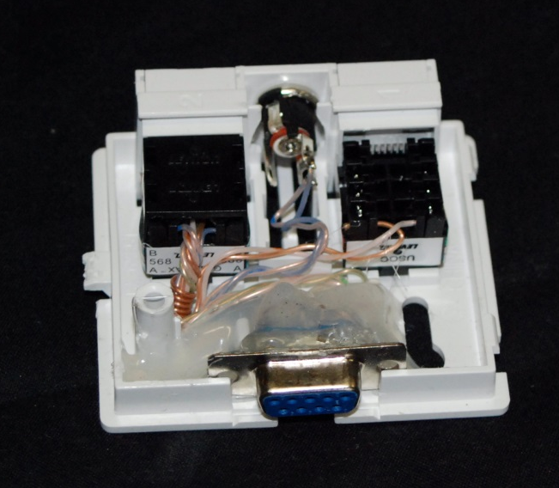
Bl/Wh Red+ Brown Tip +
Wh/Bl Yellow+ Orange Sleeve -
Or/Wh Gray Start Common
Wh/Or Green Normally Open
Gr/Wh P3 1 DB9 pin 2
Wh/Gr P3 2 DB9 pin 5
Br/Wh
Wh/Br P3 3 DB9 pin 3

